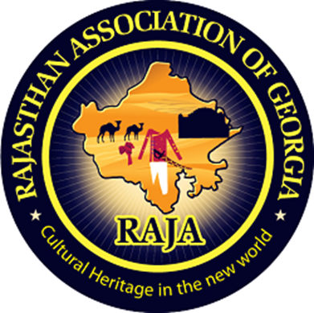

Rajasthan Association of Atlanta

Fourteenth Literacy Committee Newsletter

Literacy Secretary: Rakhi Poonia (2020-21)

How to become a human resource manager in Atlanta and in Georgia?

Attitude of gratitude:

I’d first like to thank my nominators Sunil Mathur sir, Aashu Bhai Sahab, Brij sir, Dinesh Raj sir, Sudhir Agarwal sir, Sankalp Mathur DevDarshan sir, Pravin Soni sir, Praveen Gattani Sir, Ashok sir, Hari Mundhra sir, Dinesh Raj sir, and Anand Rathi sir for giving me the chance to help RAJA youth in capacity of its Literacy Secretary 2020-21.

Today’s newsletter required extensive as well as intensive research and analysis on my part.

I researched that being a human resource manager in Atlanta and in Georgia is a white collar and high paying job.

Introduction

This newsletter answers questions like who is a human resource manager? What are his duties? How to become a human resource manager in Atlanta and in Georgia? What are degree requirements of a human resource manager in Atlanta and in Georgia? How much do they get paid?

Chapter 1

This newsletter answers questions like who is a human resource manager?

I researched on:

[www.bls.gov › ooh › management › mobile › human-resources](http://www.bls.gov › ooh › management › mobile › human-resources)

website (April 10, 2020):

1. “Human resources managers plan, direct, and coordinate the administrative functions of an organization.”
2. “They oversee the recruiting, interviewing, and hiring of new staff; consult with top executives on strategic planning; and serve as a link between an organization's management and its employees.”



I took this picture from agcareers website.

Chapter 2

What are duties of a human resource manager?

I researched on “Human Resources Manager job with Georgia Cares 587331 website” (April 2, 2020) that:

1. “The human resource manager’s duties include developing and monitoring overall HR strategies, systems, tactics and procedures across the organization.”
2. “Their duty also includes to ensure that the organization runs smoothly and addresses important aspects from employee relations, to compliance, to benefits.”



I took this picture from uvisor.com website.

Chapter 3

What are responsibilities of human resource manager?

I researched on google.com that human resource managers are:

1. “responsible for driving the execution of HR initiatives in the areas of Associate Engagement, Learning and Development, Organizational Effectiveness, Staffing, Performance Management, Employment Practices, HR Compliance, and HR Communications.”
2. “The Sr. HRM is the primary contact for the business GM and works closely with this role and field management including directors, field managers and contact center managers in support of the business.”
3. “The role covers national operations with a workforce located in a division HQ site containing operations and contact center functions as well as remote measure technician roles across the U.S.”



I took this picture from online.rider.edu website.

Chapter 4

What are degree requirements of a human resource manager in Atlanta and in Georgia?

I did intensive and extensive research on study.com website (January 21, 2020) and found that:

1. “To become an HR manager, you would need at least a bachelor's degree; some employers require a master's degree.”
2. “Degrees are usually in human resources management, business administration or a related field. You may also need up to five years of experience.”
3. “Certification is available, but it is voluntary.”
4. “Skills include interpersonal, decision-making, organization management.”



I took this picture from herzing.edu website.

Chapter 5

How much do they get paid?

I researched on salary.com website that:

1. “The average Human Resources Manager salary in Atlanta, GA is $102,967 as of April 27, 2020, but the range typically falls between $91,246 and $115,230.”
2. “Salary ranges can vary widely depending on many important factors, including education, certifications, additional skills, the number of years you have spent in your profession.”

[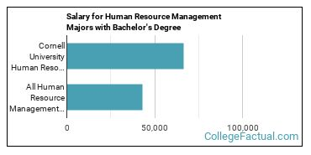](https://www.google.com/url?sa=i&url=https%3A%2F%2Fwww.collegefactual.com%2Fcolleges%2Fcornell-university%2Facademic-life%2Facademic-majors%2Fbusiness-management-marketing-sales%2Fhuman-resource-management%2F&psig=AOvVaw2Tl4b2n0lSJ3HLmHbjASk_&ust=1590510934871000&source=images&cd=vfe&ved=0CAIQjRxqFwoTCOCCgJS5z-kCFQAAAAAdAAAAABAE)

I took this picture from collegefactual.com website.

Chapter 6

Picture of human resource managers.

I have put together pictures of human resource managers. To give RAJA youth an idea of how human resource managers look and what kind of work they do.



I took this picture from managerskillwebsite.



I took this picture from bls government website.



I took this picture from career girls organization website.



I took this picture from pcg-services.com website.

Conclusion

In conclusion, human resource managers get paid very highly in Atlanta and in Georgia. Being a human resource manager is a white-collar job. Human resource managers perform multiple tasks at one time. Their job is closely associated with business administration.



Rakhi Poonia is literacy secretary of Rajasthan Association of Georgia 2020-21. She is a recipient of 2009 David Gould Scholarship sponsored by American Society for Public Administration. She is also a recipient of Pi Alpha Alpha (2006) for Public Service sponsored by Northern New Jersey chapter, USA.

She holds a Master’s in history from University of Delhi (India) and Master’s in Public Administration from University of Rajasthan, India.

Rakhi has also taught courses in Political Science at Rutgers the State University of New Jersey 2004-2008.

She has published almost 40 books on amazon.com as literacy secretary of RAJA. Her books cover a variety of subjects like business, children’s books, public service books, and education books. Rakhi Poonia books are available on amazon.com.

She lives in Atlanta, Georgia with her husband Engineer Anil Poonia and eight-year-old son Aaron Poonia. Aaron is an extraordinary child and a recipient of Star Galaxy award 2020 at Settles Bridge Elementary School. He always makes his parents proud.

Rakhi Poonia writes business books as literacy secretary of RAJA to generate employment among youth. To build human resource capital. To help small and medium sized businesses move forward and generate profits. To help those who want to dream big and work towards their goal. Every dream is achievable.

Rakhi Poonia writes children’s books because children are our future. Child is father of man. To make a child smile is the biggest wealth. Children are gift of god. The way a society treats its children speaks volumes about that society.

Rakhi Poonia writes public service books to instill value of public service amongst RAJA youth.

Rakhi Poonia writes education books to help RAJA youth attain their education goals.

As RAJA literacy secretary Rakhi Poonia has published more than 40 books on amazon.com

To buy her books type rakhi poonia books in search section of amazon.com



**PUBLIC SERVICE SONGS FOR CHILDREN**

By RAKHI POONIA

(New!)

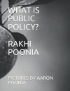

**WHAT IS PUBLIC POLICY?**

By RAKHI POONIA

(New!)

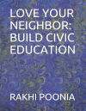

**LOVE YOUR NEIGHBOR: BUILD CIVIC EDUCATION**

By RAKHI POONIA

(New!)



**CLEANLINESS IS NEXT TO GODLINESS**

By RAKHI POONIA

New!

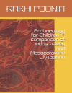

**Archaeology for Children: A comparison of Indus Valley and Indus Valley Civilization**

By RAKHI POONIA

New!

Education book 1



Education book 2



Public service book 1

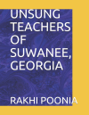

Public service book 2

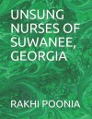

Public service book 3

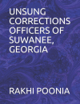

More than 10 business books published on amazon.com by Rakhi Poonia as RAJA literacy secretary



Rakhi Poonia is a recipient of percentile 96 in GRE test verbal section USA after having studied 3,800 words in English, 13 GRE books, and every test on ETS website.

Hence, she has written her most recent book GRE RESOURCES on amazon.com to help RAJA youth get admission in a dream university of their choice.

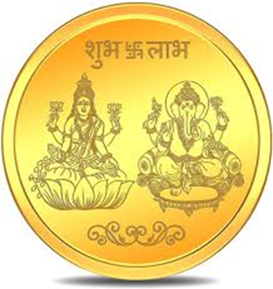

I took this picture from flipkart.com website.