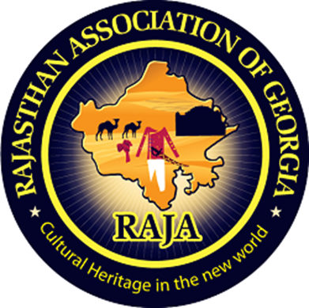

Rajasthan Association of Atlanta

Tenth Literacy Committee Newsletter

Literacy Secretary: Rakhi Poonia (2020-21).

How to become a pharmacist in Atlanta and in Georgia?

Greetings!

Happy Akshaya Tritiya 2020 to all RAJA members.

“Akshaya Tritiya is being celebrated across India today. The word Akshaya means “never diminishing” as the festival is associated with wealth, prosperity and happiness. It is also known as 'Akha Teej', an annual spring festival of Hindus and Jains. It is celebrated on the third day of Vaishakh month.” (Retrieved from times of India).



Image from freepik.com

**Attitude of gratitude:**

I’d first like to thank my nominators Sunil Mathur sir, Aashu Bhai Sahab, Brij sir, Dinesh Raj sir, Sudhir Agarwal sir, Sankalp Mathur DevDarshan sir, Pravin Soni sir, Praveen Gattani Sir, Ashok sir, Hari Mundhra sir, Dinesh Raj sir, and Anand Rathi sir for giving me the chance to help RAJA youth in capacity of its Literacy Secretary 2020-21.

Introduction:

Today’s newsletter required extensive as well as intensive

research and analysis on my part.

I researched that being a pharmacist is a white-collar job in USA. Pharmacists get paid very highly.

To learn more about how to become one, which colleges to apply to, and how much do pharmacists get paid read this newsletter.

Chapter 1

What are requirements to become a pharmacist in Atlanta and in Georgia?

I researched on study.com (July 22, 2019) and found that:

1. “Individuals who intend to become licensed pharmacists in the state of Georgia are required to complete a degree program at an accredited school of pharmacy.”
2. “Aspiring pharmacists must also complete an internship and pass a board-approved examination before they can qualify for licensure.”

Chapter 2

# How many pharmacy schools are in the state of Georgia?

# I research on <https://www.valdosta.edu>:

# “There are three pharmacy schools in the state of Georgia.”

# “[Mercer University, Southern School of Pharmacy (Atlanta)](http://www.mercer.edu/pharmacy/) [South University School of Pharmacy (Savannah)](http://www.southuniversity.edu/nursing-and-health-professions-programs/pharmacy-degrees-29211.aspx), [University of Georgia College of Pharmacy (Athens)](http://www.uga.edu/academics/pharmacy.html).”

# Chapter 3

# What degree does Georgia State offer in pharmacy?

# I researched on google that:

# “The degree offered in pharmacy is the Doctor of Pharmacy.”

# Source: catalog.gcsu.edu › current › Preprofessional-Program ›

# Chapter 4

How long does it take to become a pharmacist in Georgia?

I researched on google.com (article dated July 22, 2019):

“The school offers a PharmD degree program. The program includes four years of study beyond the required two years of pre-professional coursework.”

Chapter 5

How difficult is pharmacy school?

I researched on forums.studentdoctor.net › threads › how-difficult-is-phar. (dated September 12, 2007):

1. “Pharmacy school is not that difficult.”
2. “It's all about which school you go to. Having said that, a lot of schools have an attrition rate of more than 10% as provided by some SDN members on this thread.”

Chapter 6

What skills do you need to be a pharmacist?

I researched on CareerAddict (an article dated Dec 1,

2017). The skills needed to become a pharmacist are:

a. “Accuracy. When it comes to the pharmaceutical

industry, attention to detail is literally a matter of life

and death – and there is no room for error.”

b. “Integrity.”

c. “Science & Math Skills.”

d. “Interpersonal Skills.”

e. “Communication Skills.”

f. “Advocacy.”

g. “Management Skills.”

h. “Ability to Multitask.”

Chapter 7

What field of pharmacy makes the most money?

1. I researched on the website www.pharmacytimes.com › alex-barker-pharmd › 2016/04: (article dated Apr 13, 2016).
2. “Satellite pharmacists and nuclear pharmacists saw significant increases in hourly wages, and nuclear pharmacists have surpassed clinical pharmacists as the highest-paid specialty.”
3. “Pharmacists on the West Coast earn the most, making an average of $68.07 per hour, or $141,600 per year.”

Chapter 8

What are duties of a pharmacist?

I researched on Monster.com and found:

Pharmacist Job Responsibilities include:

1. “Serving patients by preparing medications, giving pharmacological information to multidisciplinary health care team, and monitoring patient drug therapies.”
2. “Preparing medications by reviewing and interpreting

physician orders and detecting therapeutic

incompatibilities.”

Chapter 9

What are strengths of a pharmacist?

I researched on google. An article dated October 20, 2015.

I found that:

1. “Typical strengths include good communication skills, ascertaining others' needs, patience, dependability, accountability, flexibility, paying attention to detail, and problem solving.”

Chapter 10

Pictures of pharmacists on duty in 2020 in USA.



Image from bls.gov



Image from forbes.com



Image from pharmacy.me.org

About Literacy Secretary (2020-21).

Rakhi Poonia

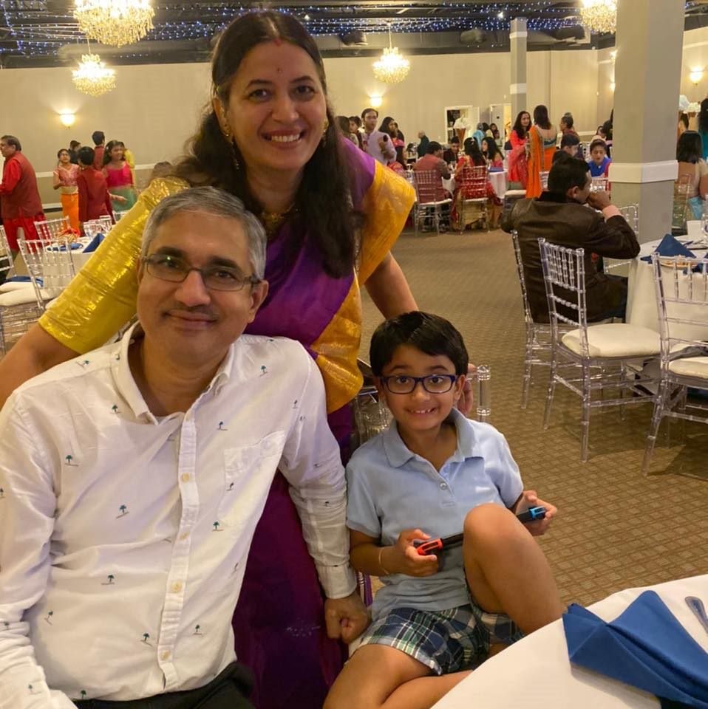

Rakhi Poonia is literacy secretary of Rajasthan Association of Atlanta 2020-21. She is a recipient of 2009 David Gould Scholarship sponsored by American Society for Public Administration. She is also a recipient of Pi Alpha Alpha (2006) for Public Service sponsored by Northern New Jersey chapter, USA.

She holds a Master’s in history from University of Delhi (India) and Master’s in Public Administration from University of Rajasthan, India.

Rakhi has also taught courses in Political Science at Rutgers the State University of New Jersey 2004-2008.

She has published 10 business books. She has also published 4 children’s books. Rakhi Poonia books are available on amazon.com. She lives in Atlanta, Georgia with her husband Engineer Anil Poonia and eight-year-old son Aaron Poonia. Aaron is an extraordinary child and a recipient of Star Galaxy award 2020 at Settles Bridge Elementary School. He always makes his parents proud.

Rakhi Poonia writes business books to generate employment among youth. To help small and medium sized businesses move forward and generate profits. To help those who want to dream big and work towards their goal. Every dream is achievable.

Rakhi Poonia writes children’s books because children are our future. Child is father of man. To make a child smile is the biggest wealth. Children are gift of god. The way a society treats its children speaks volumes about that society.

The children’s books are intended to benefit children. To help them excel academically, in sports, in health, to build attitude of gratitude and a positive outlook towards life.

Books published by Rakhi Poonia on amazon.com.

Business books.

1.



2.



3.



4.

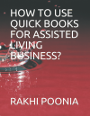

5.



6.



7.



8.



9.



10.



Children’s books written by Rakhi Poonia on amazon.com are:

1.

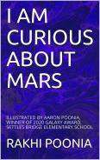

2.



3.



4.

