

**Literacy Committee Weekly Newsletter: (March 9, 2020)**

**Literacy Secretary: Rakhi Poonia**

**BA, MA, MPA, Course Instructor**

**Political Science, Rutgers University-**

**Newark, USA 2004-2008**

**Education Secretary: Dr. Anu Sally Narula**

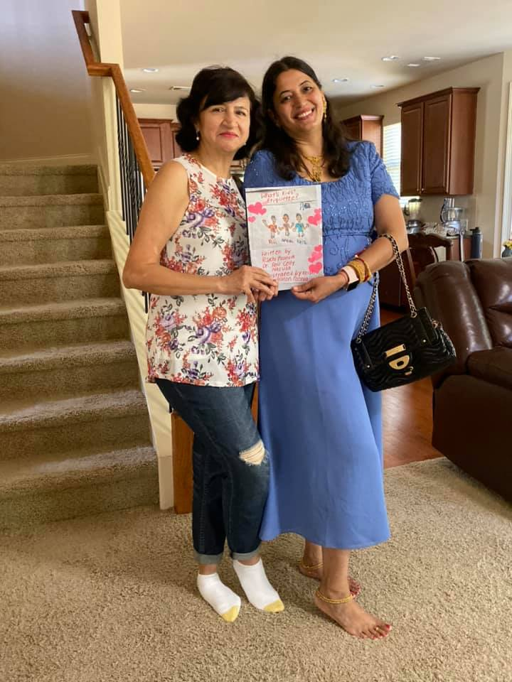

**Subject: This third literacy committee newsletter is about**

**how to become a doctor in Atlanta, Georgia.**

**The next weekly literacy committee newsletter if going to**

**focus on how to prepare RAJA youth who want to become**

**engineer in Atlanta, Georgia.**

**I hope this information is useful to RAJA youth and other**

**RAJA members.**

**Goal: To Prepare RAJA youth for high paying, white collar**

**jobs in 2020 and future. How can RAJA youth of diverse**

**backgrounds and career levels learn from, and encourage,**

**one another? How to prepare RAJA youth where they are in**

**a capacity to generate funds and be in a capacity to work in**

**their organization, bank, or business as a team. I say this**

**because research in United States shows that future belongs**

**to those who collaborate. Youth are most important as they**

**are our future.**

**We need to prepare youth for jobs that interest youth**

**because if youth do what they like they are likely to excel in**

**it.**

**Respected seniors, elders, colleagues, ladies, gentlemen,**

**friends, and above all RAJA youth, as new literacy secretary**

**of RAJA together with Dr. Anu Narula, I researched for**

**how to become a doctor in 2020 and beyond in Atlanta,**

**Georgia, USA, to help RAJA youth for this highly paying**

**job and help them settle down.**

**Getting guidance from respected Mathur sir who told me**

**to help RAJA youth in multiple ways for vocational and**

**professional jobs in present and future. He told me**

**that in 2020-21 focus of RAJA literacy committee will be to**

**prepare RAJA youth for white collar jobs in present and**

**future. Also, to focus on jobs that interest them and to bring**

**out the best in them.**

**My name is Rakhi Poonia. I have taught at a vocational**

**training institute at Jaipur, Rajasthan. I have also taught at**

**Rutgers the state University of New Jersey courses in**

**Political Science 2004-2008, the most diverse University in**

**United States over the past 15 years according to U.S. News**

**and World Reports. I have published five children’s books**

**in collaboration on amazon.com. So, I took to the job of new**

**literacy secretary of RAJA together with Dr. Anu Narula**

**like a fish to water.**

**I am humbled and honored to be appointed as 2020-21**

**RAJA literacy Secretary together with Dr. Anu Narula.**

**I’d first like to thank my nominators Sunil Mathur sir,**

**Aashu Bhai Sahab, Brij sir, Dinesh Raj sir, Sudhir Agarwal**

**sir, Sankalp Mathur DevDarshan sir, Pravin Soni sir,**

**Praveen Gattani Sir, Ashok sir, Hari Mundhra sir, Dinesh**

**Raj sir, and Anand Rathi sir for giving me the chance to**

**play the vital role of literacy secretary together with Dr. Anu**

**Narula. Since, youth and children are our future.**

**Cutting long story short, today’s newsletter required**

**extensive as well as intensive research and analysis on my**

**part together with Dr. Anu Narula.**

**Here are ways in which RAJA youth can become doctor in**

**Atlanta, Georgia.**

**According to https://www.mag.org**

**“The average tuition for residents attending private medical**

**schools in their home state is $42,811. The average tuition at**

**Georgia’s private medical schools in $41,043. A large**

**percentage of students currently enrolled in Georgia’s**

**medical schools are residents of the state.”**

**After researching on medsmarter.com (phone number**

**1.800.979.5850), I found that there are four medical schools**

**in Georgia. Their degree programs, tuition and**

**requirements are as follows.**

**“There are currently only four medical schools in Georgia.**

**One is public, while the other three are private universities.”**

**Essential Information About Medical Schools in Georgia”**

**“Each of Georgia’s four medical schools offers its own**

**distinct educational style for future physicians. All of these**

**programs fulfill the educational requirements for US**

**medical licensing.”**

**“If you’re looking for medical schools in Atlanta, Georgia,**

**there are two. Emory University and Morehouse School of**

**Medicine are located in Atlanta. Augusta University is**

**named after its home city. Mercer University has four**

**campuses in the State of Georgia: Macon, Savannah,**

**Columbus and Atlanta.”**

**“Medical Schools in Georgia Requirements**

**Here are the requirements for the four medical schools**

**located in the State of Georgia:**

**1. Augusta University – Augusta, GA**

**Augusta Medical College of Georgia**

**Medical College of Georgia and Georgia Health Sciences**

**University combined to create one school known as Augusta**

**University Medical College of Georgia. It’s the states only**

**public medical school. Many pre-meds who want to save as**

**much money as possible on tuition choose this institution.**

**Because of its public university status, tuition is much**

**cheaper than the Peach State’s other three med schools.**

**Augusta gives medical students access to more than 350**

**clinical training sites across the state. Get clinical experience**

**in a range of settings from city hospitals to small clinics.**

**Student gain clinical experience in a full range of medicine.**

**Augusta University Medical Degrees Offered**

**Doctor of Medicine Degree (MD)**

**Dual MD/PhD Degree**

**Medical Schools in Georgia Tuition: Augusta University**

**Georgia State Residents Estimate: $6,834 per year**

**Out-of-State or International Residents Estimate: $19,234**

**per year.”**

**“2. Mercer University – Macon, Savannah, Columbus and**

**Atlanta, GA**

**Mercer University School of Medicine Macon Campus**

**The Mercer University School of Medicine only accepts pre-**

**meds who are legal residents of Georgia. That means it does**

**not accept foreign pre-meds, medical students or graduates**

**unless legal residency is established.**

**There are actually three Mercer University campuses:**

**Macon, GA**

**Savannah, GA**

**Columbus, GA**

**Atlanta, GA**

**Instead of lectures, Mercer teaches using a self-directed**

**learning approach. The curriculum focuses on problem-**

**based learning, providing clinical exposure to med students**

**within the first few weeks.**

**There are small student groups with group coursework**

**related to problem-solving. Students have direct access to**

**faculty, who are more like tutors than instructors.**

**Third-year medical students participate in clinical rotations,**

**and fourth-years serve clerkships. Their programs are**

**offered on the university’s Columbus, GA campus.**

**Mercer University Medical Degrees Offered**

**Doctor of Medicine Degree (MD)**

**Master of Science in Biomedical Sciences Degree**

**Master of Science in Preclinical Sciences Degree**

**Master of Family Therapy Degree**

**Medical Schools in Georgia Tuition: Mercer University**

**Estimate: $15,204 per year**

**The 2 Medical Schools in Atlanta, Georgia**

**Currently, only there are only two main medical schools in**

**Atlanta, Georgia. Although Mercer University does have a**

**campus there, its main facility is not housed in Atlanta.”**

**“3. Emory University – Atlanta, GA**

**Emory University School of Medicine**

**This is one of the two main medical schools in Atlanta,**

**Georgia. Emory University School of Medicine offers an**

**innovative curriculum. First-year medical students gain**

**outpatient experience. Clinical rotations take place in a wide**

**range of clinical sites.**

**Emory School of Medicine programs are unique because**

**they provide students with extensive amounts of clinical**

**experience. Skills training begins very early on and**

**continues throughout the program. Students get experience**

**in a wide array of clinical settings while getting access to the**

**diverse patient population throughout the city.**

**Emory University Medical Degrees Offered**

**Doctor of Medicine Degree (MD)**

**Doctor of Philosophy in Biological and Biomedical Sciences**

**Degree (PhD)**

**Doctor of Physical Therapy Degree (DPT)**

**Master of Medical Science Anesthesiology Degree (MMSc)**

**Master of Medical Science Genetic Counseling (MMSc)**

**Master of Medical Science Physician Assistant (MMSc-PA)**

**Bachelor of Medical Science Medical Imaging (BMSc)**

**Medical Schools in Georgia Tuition: Emory University**

**Estimate: $41, 940 per year**

**4. Morehouse University – Atlanta, GA**

**Morehouse is the other of the two medical schools in Atlanta,**

**Georgia. It’s one of Atlanta’s famous historically Black**

**colleges and universities (HBCUs). The Morehouse School of**

**Medicine is committed to the diverse makeup of its student**

**body. Pre-meds with underrepresented ethnic backgrounds,**

**such as international students are encouraged to apply.**

**The med school curriculum at Morehouse includes**

**classroom lectures, labs and clinical training. This HBCU is**

**affiliated with Grady Memorial Hospital, a teaching**

**institution, and many other healthcare facilities within the area.**

**Morehouse University Medical Degrees Offered**

**Doctor of Medicine Degree (MD)**

**Graduate Education in Biomedical Sciences Degree (Ph.D. and M.S.)**

**Graduate Education in Public Health Degree (M.P.H.)**

**Master of Clinical Research Degree (MSCR)**

**Medical Schools in Georgia Tuition: Morehouse University**

**Estimate: $24,568 per year**

**Requirements for Becoming a Doctor in the US**

**The state of Georgia requires anyone practicing medicine to**

**be licensed. Requirements for becoming a licensed physician**

**include:**

**US citizenship or affidavit of legal alien status for foreign**

**medical students.**

**Successful completion of a medical program at an approved**

**school of medicine.**

**Pass US medical licensing exams known as the USMLEs**

**Verification of postgraduate residency training.”**

**“How to Get into Medical School So You Can Become a US**

**Doctor?**

**Most United States med schools require that you pass the**

**MCAT for admissions. All four of the medical schools in**

**Georgia require passing MCAT scores for acceptance into**

**their programs.**

**Many med school students turn** **to test prep courses and**

**tutoring to pass the MCAT exam. MedSmarter is an**

**industry leader in the Atlanta area. Their programs have a**

**good track record when it comes to helping students and**

**foreign doctors pass this licensing exam to practice medicine**

**in America.”**

**“MCAT preparation course are available on Suwanee,**

**GA campus. Learn in small class settings, so you get the one-**

**on-one assistance you need. Or get one-on-one MCAT**

**tutoring from licensed healthcare professionals. Tutoring**

**services are offered on their Suwanee campus or via video**

**conferencing online.**

[](https://www.google.com/url?sa=i&url=https%3A%2F%2Fwww.indiatvnews.com%2Flifestyle%2Fbooks-culture-happy-holi-2020-images-wallpapers-best-wishes-whatsapp-messages-facebook-status-instagram-pictures-595737&psig=AOvVaw318kRwAu4aChfAOtHN_or0&ust=1583845801346000&source=images&cd=vfe&ved=0CAIQjRxqFwoTCMiluse7jegCFQAAAAAdAAAAABAJ)

This Holi 2020 use this newsletter to build a bright present and future.