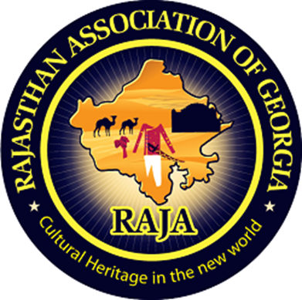

Literacy Committee Weekly Newsletter: (March 30, 2020)

Literacy Secretary: Rakhi Poonia

BA, MA, MPA, Course Instructor Political

Science, Rutgers University- Newark, New

Jersey, USA 2004-2008.

Pi Alpha Alpha recipient for Public Service

sponsored by American Society for Public

Administration (2006).

David Gould Scholar for Comparative

Public Administration sponsored by

American Society for Public

Administration (2009).

Wish you all a very happy Rajasthan Day 2020 today. Education today means better life tomorrow. Preparing RAJA youth for a bright, prosperous, and progressive future. After reading RAJA weekly newsletters I can assure you that every RAJA youth will get a white-collar job. RAJA weekly newsletters are thoroughly researched.

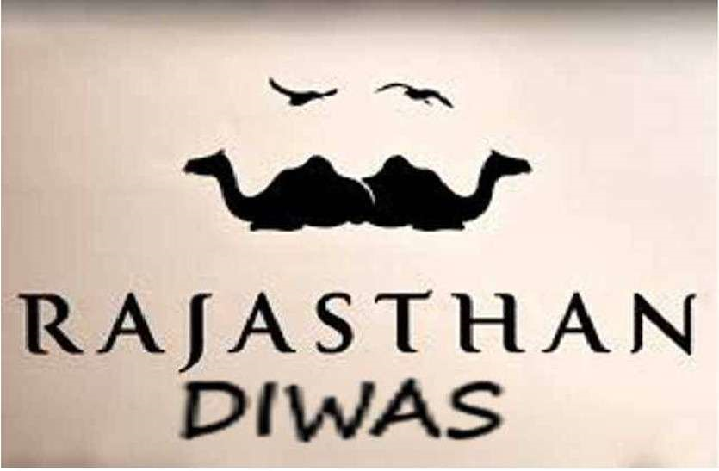

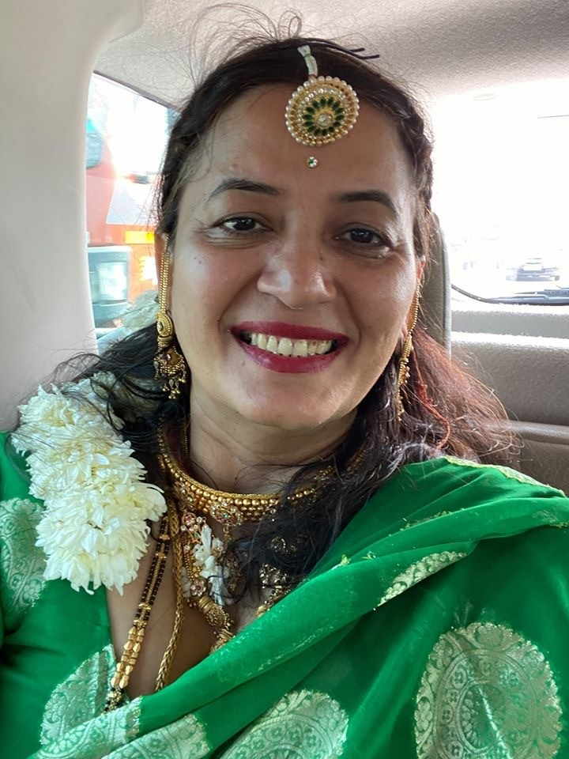

Subject: This sixth literacy committee newsletter is about how to become a dentist in Atlanta, Georgia. The next weekly literacy committee newsletter if going to focus on how to prepare RAJA youth who want to become a Pediatrician in Atlanta and in Georgia. I hope this information is useful to RAJA youth and other RAJA members.

Goal: To Prepare RAJA youth for high paying, white collar jobs in 2020 and future. How can RAJA youth of diverse backgrounds and career levels learn from, and encourage, one another? How to prepare RAJA youth where they are in a capacity to generate funds and be in a capacity to work in their organization, bank, or business as a team. I say this because research in United States shows that future belongs to those who collaborate. Youth are most important as they are our future. We need to prepare youth for jobs that interest youth because if youth do what they like they are likely to excel in it.

Dear RAJA youth dream big. Every dream is achievable. Nothing succeeds like success. There is nothing called impossible. Even impossible says I AM POSSIBLE.

Respected seniors, elders, colleagues, ladies, gentlemen, friends, and above all RAJA youth, as new literacy secretary of RAJA, I researched on how to become a dentist in 2020 and beyond in Atlanta, Georgia, USA, to help RAJA youth for this highly paying job and help them settle down.

Getting guidance from respected Mathur sir who told me to help RAJA youth in multiple ways for vocational and professional jobs in present and future. He told me that in 2020-21 focus of RAJA literacy committee will be to prepare RAJA youth for white collar jobs in present and future. Also, to focus on jobs that interest them and to bring out the best in them.

My name is Rakhi Poonia. I have taught at a vocational training institute at Jaipur, Rajasthan. I have also taught at Rutgers the State University of New Jersey courses in Political Science 2004-2008, the most diverse University in United States over the past 15 years according to U.S. News and World Reports. I have published seven children’s books in collaboration on amazon.com. My eighth book (a business book), “Quick Books Tutorial Made Easy,” in progress on amazon.com. So, I took to the job of new literacy secretary of RAJA like a fish to water.

I am humbled and honored to be appointed as 2020-21 RAJA literacy Secretary. I’d first like to thank my nominators Sunil Mathur sir, Aashu Bhai Sahab, Brij sir, Dinesh Raj sir, Sudhir Agarwal sir, Sankalp Mathur DevDarshan sir, Pravin Soni sir, Praveen Gattani Sir, Ashok sir, Hari Mundhra sir, Dinesh Raj sir, and Anand Rathi sir for giving me the chance to play the vital role of literacy secretary. Since, youth and children are our future.

Cutting long story short, today’s newsletter required extensive as well as intensive research and analysis on my part.

Figure 1

1.I researched on google.com and found, “In order to **become** a licensed **dentist** in **Georgia**, students must complete an American **Dental** Association (ADA) accredited program, pass the ADA National Board Examination, and submit an application and sealed transcript to the **Georgia** Licensing Board.” (Retrieved on July 27, 2019).

Figure 2

2. I researched on study.com how_long_does_it_take_to_be_a_dentist and found out

“The education requirements for becoming a **dentist** are

completing a bachelor's degree, passing the **Dental**

Admissions Test (DAT), and completing four years of

study to earn a Doctor of **Dental** Surgery or Doctor of

**Dental** Medicine. You must obtain licensure from your

state board of **dentistry** to practice in the profession.” (Retrieved on January 2, 2019).

Figure 3

3. I researched on

[www.orthodonticproductsonline.com › treatment-products › accessories](http://www.orthodonticproductsonline.com › treatment-products › accessories)

Are dentists rich?

“In a recent survey, The **Wealthy Dentist** asked **dentists** if they consider themselves **wealthy**—and two out of three **dentists** said no, they are not in fact **wealthy**. ... Other **dentists** are delighted to be **wealthy**. "Statistics show that **dentists** average about $180,000 per year, putting them in the top 5% of earners in America.Feb 11, 2008.”

Figure 4

4. I researched on study.com › atlanta_dental_schools.

“Is dental school difficult? It is **difficult** and very competitive to get into **dental school**, because more and more students are applying each year.”

Figure 5

5. According to [studentloanhero.com › featured › dental-school-debt-worth-it](https://www.google.com/url?sa=t&rct=j&q=&esrc=s&source=web&cd=4&cad=rja&uact=8&ved=2ahUKEwid5NXn_sDoAhVJAqwKHToTDTcQFjADegQIARAQ&url=https%3A%2F%2Fstudentloanhero.com%2Ffeatured%2Fdental-school-debt-worth-it%2F&usg=AOvVaw1yH4bVgc7iVpWkw6FsAyPH)

“Do you get paid during dental school?

The median pay for dentists is $153,900, according to Bureau of Labor Statistics data. New dental school graduates won't be earning this much right away. But they will start with relatively high pay, with a median entry-level salary of $118,800, according to PayScale.” (Retrieved on Apr 3, 2018).”

Figure 6

6. According to, forums.studentdoctor.net › threads › specializing-is-it-worth-it.1178370

“Is it worth specializing in dentistry? Like presidential candidate Bernie Sanders said, oral surgeons have the highest average income of the **dental** specialists. It is generally easier to make good money as an OMFS than any other specialty. Now as far as the other specialties go, the desire for income isn't a good reason to **specialize**.” (Retrieved on Jan 11, 2016).

Figure 7

7. According to

www.quora.com › Is-medicine-really-harder-than-dentistry

“Is dentistry harder than medicine? You don't just learn about the teeth and mouth; you learn about the whole body. It is said to be harder than Medicine. ... Dentistry is competitive, probs not as competitive as medicine. But it's still hard to get into.”

Figure 8

8. I researched on bing.com and google.com most recent information available on Atlanta Dental Schools. (Retrieved on February 08, 2019).

**“Atlanta Dental Schools with Degree Program Information**

Feb 08, 2019

The Atlanta area has at least six colleges that offer dental hygiene and dental assisting programs. Learn about the degree programs, admission info and program requirements for three of these schools, all within 20 miles of the city center, and make an informed education decision.

## **Dental Hygiene School Options in Atlanta**

The Atlanta region is home to several schools that have programs in dental assisting and dental hygiene. Students seeking the academic training to become licensed dentists must look elsewhere because there are no dentistry programs within 50 miles of Atlanta. This article looks at three public schools within a half-hour's drive of downtown Atlanta that offer undergraduate degree programs in dental hygiene.

In addition to providing information about the degree programs, the article also offers a table of information about each school that includes enrollment figures, tuition and graduation rates. A paragraph of information about a few other Atlanta-area schools with dental hygiene and dental assisting programs is provided at the end of the article.

* **Atlanta Technical College** (ATC) offers a stand-alone course online that provides an overview of dental careers as well as an associate's degree program in dental hygiene. This school is just four miles from downtown.
* **Clayton State University**, a 4-year school approximately 16 miles south of downtown Atlanta, allows students to earn a joint bachelor's degree in dental hygiene and health care management.
* The Dunwoody campus of **Georgia Perimeter College** (GPC) houses the school's Dental Hygiene Clinic and is about 19 miles from downtown. It offers an associate's degree program in dental hygiene.

## **Comparison of Schools**

Individuals need to be aware of many important facts about a school when they are making a decision regarding their training. This table presents information in a format that makes comparisons simple.

|  |  |  |  |
| --- | --- | --- | --- |
|  | **Atlanta Technical College** | **Clayton State University** | **Georgia Perimeter College - Dunwoody** |
| *School Type* | 2-year; public | 4-year; public | 2-year; public |
| *Total Enrollment (2017)* | 4,098* | 7,003* | 18,732* |
| *Campus Setting* | Large city | Large suburb | Large city |
| *Tuition & Fees (2017-2018)* | $2,816 in-state; $4,952 out-of-state* | $5,419 in-state; $15,880 out-of-state* | $3,304 in-state; $9,501 out-of-state* |
| *% of First-Year Students Receiving Any Form of Financial Aid (2016-2017)* | 94%* | 94%* | 74%* |
| *Acceptance Rate (2017)* | N/A - Open admissions | 42%* | 59%* |
| *Retention Rate (2017)* | 58% for full-time students* | 68% for full-time students* | 67% for full-time students* |
| *Undergraduate Graduation Rate* | 44% (Students began in 2014)* | 30% (Students began in 2011)* | 13% (Students began in 2014)* |

*Source: *NCES College Navigator.*

### **Atlanta Technical College**

ATC is part of the Technical College System of Georgia. While the school has an open admissions policy, students entering the dental hygiene program are required to submit proof of hepatitis B and tuberculosis immunizations.

#### **Associate of Applied Science in Dental Hygiene**

ATC's Associate of Applied Science (AAS) program in dental hygiene requires foundational courses in such subjects as physiology and microbiology, along with general education disciplines like math and English. Students additionally take classes in sociology and psychology. Specialized study in areas such as radiology, oral pathology, biochemistry, and periodontology are also part of the curriculum and often include both laboratory and lecture components.

### **Clayton State University**

Clayton State's dental hygiene program retains five faculty members, all of whom are registered dental hygienists or dentists. The Bachelor of Science (BS) program in dental hygiene is for students who are not already practicing professionally. The school offers a separate bachelor's degree program for those who have an associate degree in dental hygiene and are already registered dental hygienists.

#### **Bachelor of Science in Dental Hygiene**

This program comprises study in such subjects as dental materials, periodontics, dental anatomy, and dental histology. Coursework in clinical and dental pharmacology is also required, as are classes in nutrition and community dental health. Students choose from electives that cover topics including health care human resource management, epidemiology, public health administration, and pathophysiology, to name a few.

### **Georgia Perimeter College - Dunwoody**

Before applying for the dental hygiene program at GPC, students must complete prerequisite courses in biology, some with laboratory study included. The dental hygiene program admissions process also includes a criminal background check.

#### **Associate of Science in Dental Hygiene**

GPC's dental hygiene program comprises study of topics such as public health, periodontics, and dental radiology. Students additionally undergo general education classes in subjects including chemistry, composition, and history, among others. Required laboratory courses allow students to provide professional care to patients under instructor supervision.

## **Other School Options**

In addition to those above, there are a few schools further outside Atlanta that also have dental assisting or dental hygiene programs. **Gwinnett Technical College** is about 28 miles from downtown Atlanta and houses diploma programs in dental assisting and dental laboratory technology, as well as certificate programs in both basic and advanced dental assisting. **Lanier Technical College** (LTC) awards a diploma in dental assisting at its Forsyth campus in Cumming, GA, which is about 37 miles from downtown Atlanta. LTC also offers an Associate of Science in Dental Hygiene program.”