

Rajasthan Association of Atlanta

Twelfth Literacy Committee Newsletter

Literacy Secretary: Rakhi Poonia (2020-21).

How to become Computer and Information Systems Manager in Atlanta and in Georgia?

Attitude of gratitude:

I’d first like to thank my nominators Sunil Mathur sir, Aashu Bhai Sahab, Brij sir, Dinesh Raj sir, Sudhir Agarwal sir, Sankalp Mathur DevDarshan sir, Pravin Soni sir, Praveen Gattani Sir, Ashok sir, Hari Mundhra sir, Dinesh Raj sir, and Anand Rathi sir for giving me the chance to help RAJA youth in capacity of its Literacy Secretary 2020-21.

Today’s newsletter required extensive as well as intensive research and analysis on my part.

I researched that being a Computer and Information Systems Manager in Atlanta and in Georgia is a white collar and high paying job.

Introduction

This newsletter answers questions like how to become a Computer and Information Systems Manager in Atlanta and in Georgia? What are degree requirements of a Computer and Information Systems Manager in Atlanta and in Georgia? How much do they get paid? What are their job duties?

Chapter 1

Who is a Computer and Information Systems Manager?

I researched on

[www.newenglandcollegeonline.com website and found answer to this question.](http://www.newenglandcollegeonline.com website and found answer to this question.)

1. “Generally speaking, computer and information systems managers implement and oversee computer-related activity within a company or organization.”
2. “Working with top executives, they help determine the computing system needs for a company and then produce a plan to meet those needs.”



This image is taken from herzing.edu website.

Chapter 2

How to become a Computer and Information Systems Manager in Atlanta and in Georgia?

I researched on [www.herzing.edu](http://www.herzing.edu) website and found an answer to this question.

1. Step 1: “Enroll in a technology bachelor's degree program.”
2. Step 2: “Find an internship in the field.”
3. Step 3: “Gain work experience.”
4. Step 4: “Continue your education.”
5. Step 5: “Get the job.”



This picture is taken from herzing.edu website.

Chapter 3

What are degree requirements of a Computer and Information Systems Manager in Atlanta and in Georgia?

I researched on [www.bls.gov](http://www.bls.gov) website and found an answer to this question.

1. “bachelor's degree is required.”
2. “Computer and information systems managers normally must have a bachelor's degree in a computer- or information science–related field.”
3. “These degrees include courses in computer programming, software development, and mathematics.”



This picture is taken from salarieswiki.com.

Chapter 4

How much do Computer and Information’s Systems Managers get paid?

I researched on glassdoor.com

Computer and Information’s Systems Managers get paid “$72,403/yr”

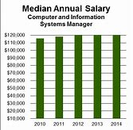

I took this picture from applemaze.com

Chapter 5

What are job duties of Computer and Information Systems Managers?

I researched on [www.newenglandcollegeonline.com](http://www.newenglandcollegeonline.com) and found out about duties of Computer and Systems Managers.

1. “Generally speaking, computer and information systems managers implement and oversee computer-related activity within a company or organization.”
2. “Working with top executives, they help determine the computing system needs for a company and then produce a plan to meet those needs.”



The source of this picture is bls.gov website.

Chapter 6

Which college to study in to become a Computer and Information Systems Manager in Atlanta and in Georgia?

I thoroughly researched on study.com and found an answer to this question.

1. “Georgia State University is a 4-year public school with highly ranked programs in management information systems.”
2. “The university offers undergraduate and graduate degrees in the field.”

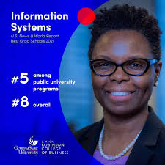

I took this image from Facebook.

Chapter 7

Pictures of Computer and Information Systems Managers in Atlanta and in Georgia.

I worked hard in assembling pictures of Computer and Information Systems Managers in Atlanta and in Georgia.

I want to give RAJA youth an impression of the environment and work conditions of Computer and Information Systems Managers in Atlanta and in Georgia.



I took this image from mytopgadgets.com



This picture is from herzingunicersity.com.



This picture is taken from kaleidoscope website.

Conclusion

To summarize Computer and Information Systems Managers are highly paid in Atlanta and in Georgia. This twelfth literacy committee newsletter has all information RAJA youth need to become Computer and Information Systems Manager in Atlanta and in Georgia. It is professionally researched with the intention of helping RAJA youth gain a white-collar job.

Note: The information in inverted commas is taken from different employment sources. I have cited sources alongside.

Rest of the newsletter is in author’s own words.

About Literacy Secretary Rajasthan Association of Georgia 2020-21

Rakhi Poonia



Rakhi Poonia is literacy secretary of Rajasthan Association of Georgia 2020-21. She is a recipient of 2009 David Gould Scholarship sponsored by American Society for Public Administration. She is also a recipient of Pi Alpha Alpha (2006) for Public Service sponsored by Northern New Jersey chapter, USA.

She holds a Master’s in history from University of Delhi (India) and Master’s in Public Administration from University of Rajasthan, India.

Rakhi has also taught courses in Political Science at Rutgers the State University of New Jersey 2004-2008.

Rakhi Poonia is recipient of several awards in USA like Pi Alpha Alpha Honor for Public Service (2006) and David Gould Scholarship sponsored by American Society for Public Administration (2009).

She has published more than 30 books on amazon.com. Her books cover a variety of subjects like business, children’s books, public service books, and education books. Rakhi Poonia books are available on amazon.com. She lives in Atlanta, Georgia with her husband Engineer Anil Poonia and eight-year-old son Aaron Poonia. Aaron is an extraordinary child and a recipient of Star Galaxy award 2020 at Settles Bridge Elementary School. He always makes his parents proud.

Rakhi Poonia writes business books to generate employment among youth. To build human resource capital. To help small and medium sized businesses move forward and generate profits. To help those who want to dream big and work towards their goal. Every dream is achievable.

Rakhi Poonia writes children’s books because children are our future. Child is father of man. To make a child smile is the biggest wealth. Children are gift of god. The way a society treats its children speaks volumes about that society.

Rakhi Poonia writes public service books to instill value of public service amongst youth.

Rakhi Poonia writes education books to help RAJA youth attain their education goals.

Books published by Rakhi Poonia are available on amazon.com.

Rakhi Poonia has written business books, children’s books, public service books, and education books with the intention of helping RAJA youth move forward and excel in their lives.

Rakhi Poonia books on amazon.com

Education book 1



Education book 2



Public service book 1

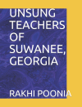

Public service book 2

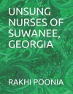

Public service book 3

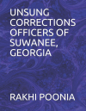

Public service book 4



Rest of books…



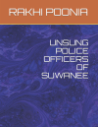













































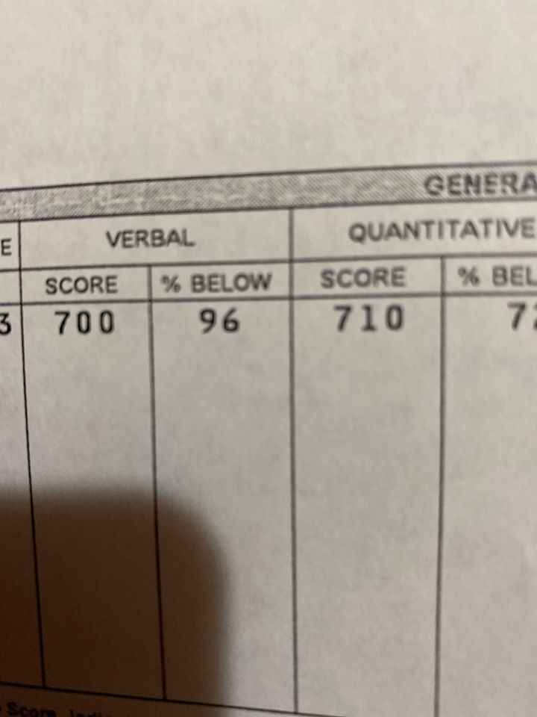

Rakhi Poonia is a recipient of percentile 96 in GRE test verbal section USA after having studied 3,800 words in English, 13 GRE books, and every test on ETS website.

Hence, she has written her most recent book GRE RESOURCES on amazon.com to help RAJA youth get admission in their dream University in Atlanta and in Georgia with full financial aid. This book is going to be available on amazon.com 24 hours from now.

Education today means better life tomorrow.

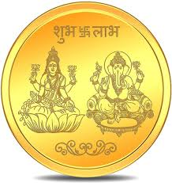

Image of laxmi ganesh from flikart website.